**Lab – 19: How to install the Azure Information Protection client.**

**Objective:** The objective of this lab is –

* To install the Azure Information Protection client in Windows 10.

In this lab, we are going to install the Azure Information Protection client so that the policy that we've configured will download to a Windows PC, and display the labels in Office applications.

**Prerequisite:** EMS Enterprise Mobility + Security E5, Windows 10 (Microsoft Office installed), but Word should not be open while doing this lab.

**Steps:**

1. Go to the Microsoft download center: **https://www.microsoft.com/en-us/download/details.aspx?id=53018**, Microsoft Azure Information Protection page will open.

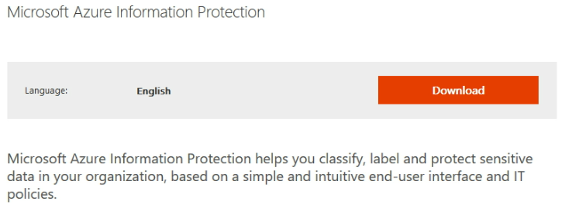

1. Expand System Requirements to check the system requirements. Supported Operating System and Supported Office versions that you can use.

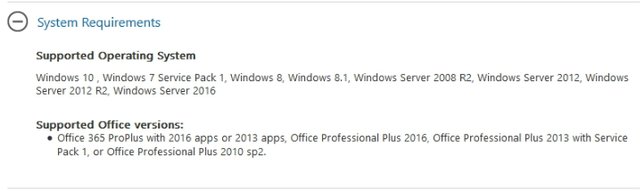

1. Click **Download** button and choose the download you want.

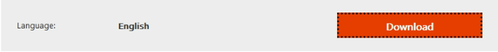

1. Here you can see 4 files, check **AzInfoProtection.exe** and click **Next** to download this file. Click **Save File** on the pop-up box for Opening AzInfoProtection.exe. This file starts to download.

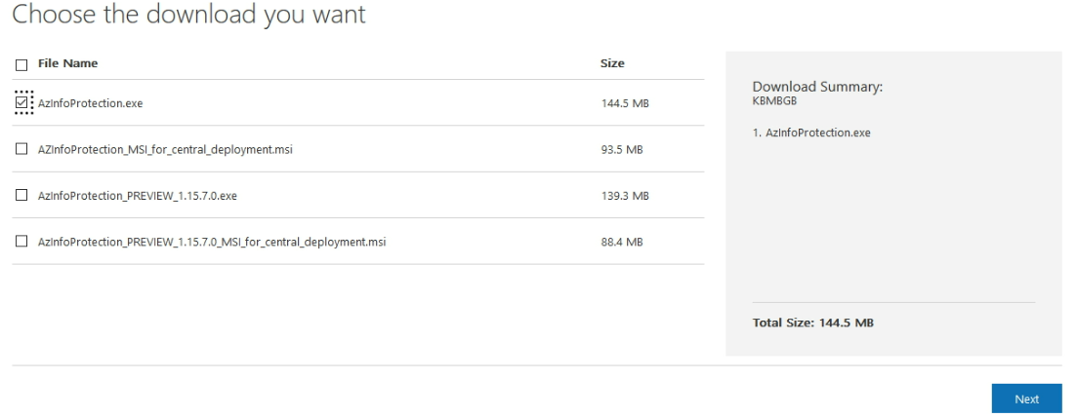

1. Run the executable that you've just downloaded, and follow the prompts to install the client.
2. For this lab, it doesn't matter whether you select the option to install a demo policy, because our policy that we've just configured will be downloaded from Azure and replace the demo policy if installed. However, you could use the demo policy option if you just wanted to experience the default labels without connecting to Azure Information Protection. For this, select **Install a demo policy** and experience Azure Information Protection by using a local policy. Then click **I Agree**. Now, the setup starts to install.

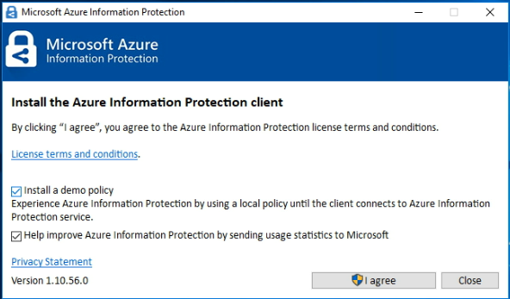

1. When **Completed Successfully** message appears, click **Close**.

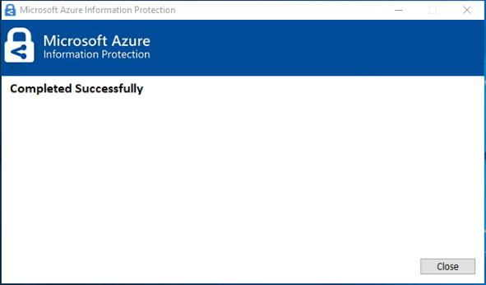

1. Now let’s verify that the installation was successful by opening Word and a new, blank document. If you are prompted to enter your user name and password, enter the details for your global administrator account.
2. A **Congratulations** page will open that represents basic instructions like - You can now label and protect your information. You can use the Information Protection bar to set the sensitivity level for your documents or emails. Read the tooltip for each label to see more information and when to use that label. When a label is set, you can select the Edit label icon to change the label. For more information click **Learn More**. Then click **Close**.

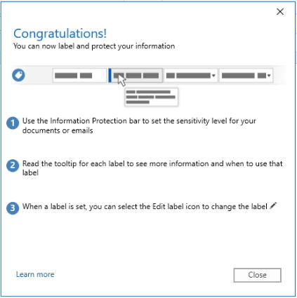

1. If you were not prompted to enter your user name and password while opening Word, you can click **Sign In** from the bar and enter your credentials to get sign in.

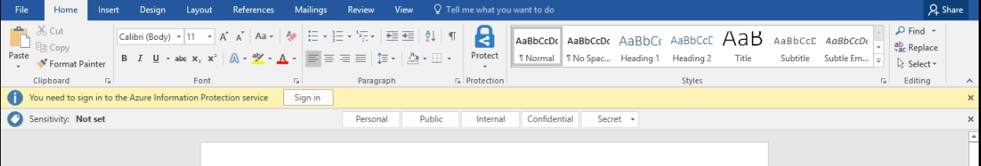

1. Now, you should see two new things: On the **Home** tab, a new Protection group, with a button named **Protect**. And, a new bar under the ribbon; the **Information Protection** bar. It displays the title of Sensitivity, and the labels that we saw in the Azure portal.





1. So, in this way you can install the Azure Information Protection client in Windows 10.